**Consider how you might find users to discuss your project idea with.**

In the technology and restaurants space, products and services generally embody one or a combination of: discovery, efficiency, novelty, and understanding.

* Discovery: “Whoa, I just found this awesome thing to eat in this restaurant at student union.”
* Efficiency: “Wow, it was really easy to acquire and learn this awesome thing.”
* Novelty: “Cheers! Look at this awesome thing I found in Dreamhack.”
* Understanding: “Now I know more about that awesome thing I ate.”

This app will empower marketing, admissions, and student affairs staff to quickly and easily create campus event apps for any occasion, like new student orientation, commencement, admissions, and homecoming. This app will:

* Share rich content, including photos, articles, and videos
* Provide maps, transit, and parking information
* Integrate social media and news feeds
* Collect user information through customized forms
* **Make it vital:**

What are the essential elements of content or services that students can't get as easily anywhere else? Helpful services using clear and simple user interface design can become more than just popular. Room bookings, sports club notifications, library services and deadline reminders can all serve to make the app 'sticky'. Stickiness is what's needed to get the sort of take-up and sustained usage which is required to make a real impact on student engagement.

An app which is both useful and good looking will be discussed and shared. It might be the first thing prospective students see when their peers enthuse about their experience of studying with you.

* **Consider the user/customer/student journey and experience:**

How does the app contribute to a satisfying experience of your institution? What are the different touch points that could be improved and simplified? What can we learn from apps from the major festivals such as Glastonbury? The EE-sponsored app has become a required download for festivalgoers in recent years. It harnesses an almost overwhelming array of events and experiences into a navigable and personal calendar allowing planning, discussion and sharing. Your university or college app could allow membership or interest in certain clubs, societies, courses and other strands to result in a tailored calendar and set of notifications. Saving the student from barrages of email – which is increasingly alien to those brought up on social media – and giving them something they can manage easily.

Once you start to add bookings, payments and reminders - academic or otherwise -that unify the student experience then you have something quite powerful. The same development can also yield interesting data ready for analysis and comparison against engagement.

* **Always think a stage ahead:**

Light-touch integration is on the increase. How can we deliver valuable services without expensive overhauls or complex interconnection with legacy systems?

From the user's perspective, mobile apps were initially about more convenient access to information that was being pushed out from the centre. Now they're about getting things done regardless of where you are. Sometimes that's finding out, sometimes it's booking, sharing, arranging or planning. What's going on today, this week, in my building? What are people saying about it? How can I get involved? There's a reason the best apps are addictive - how can you build on those conversations, interactions and transactions happening around your institution to engage students by helping them to get more out of their experience.

Apps should help you to create positive feedback loops, enabling continuous innovation. The best ones will make an increasing contribution to engagement and recruitment over time.

* **Students feedback:**

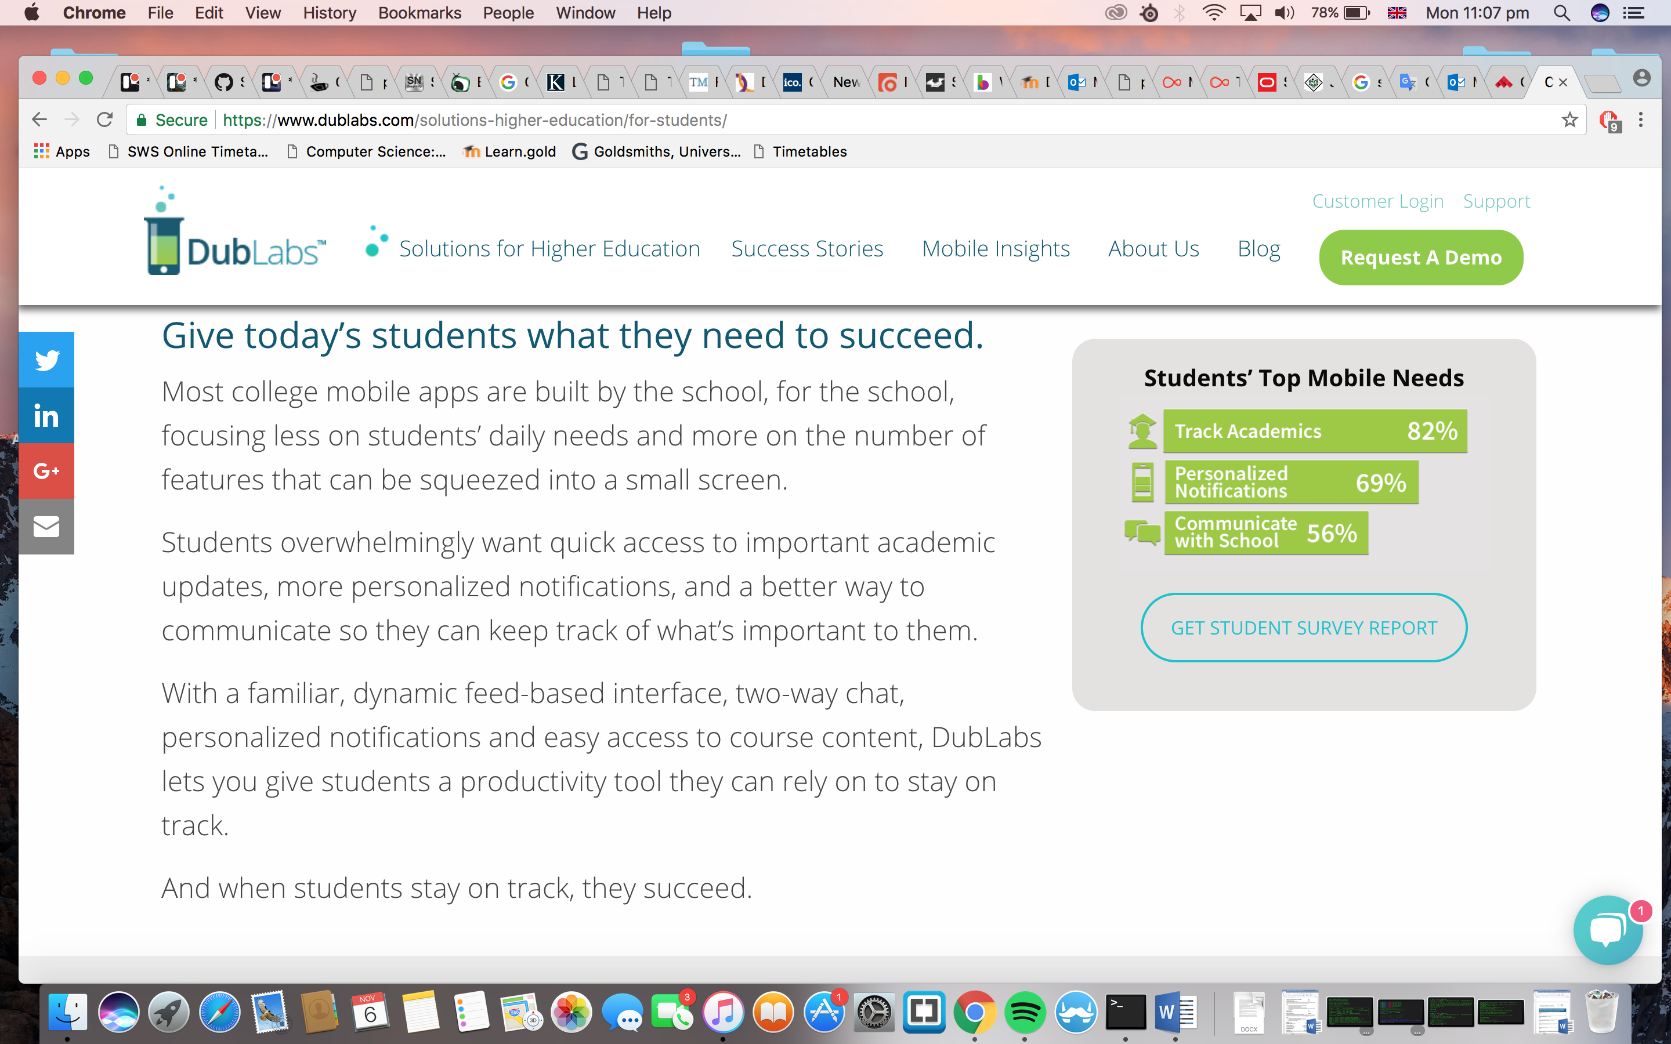Most college mobile apps are built by the school, for the school, focusing less on students’ daily needs and more on the number of features that can be squeezed into a small screen.

Students overwhelmingly want quick access to important academic updates, more personalized notifications, and a better way to communicate so they can keep track of what’s important to them.

With a familiar, dynamic feed-based interface, two-way chat, personalized notifications and easy access to course content, the app lets you give students a productivity tool they can rely on to stay on track. And when students stay on track, they succeed.